16 Show or hide HTML elements using JavaScript and toggle CSS classes dynamical.
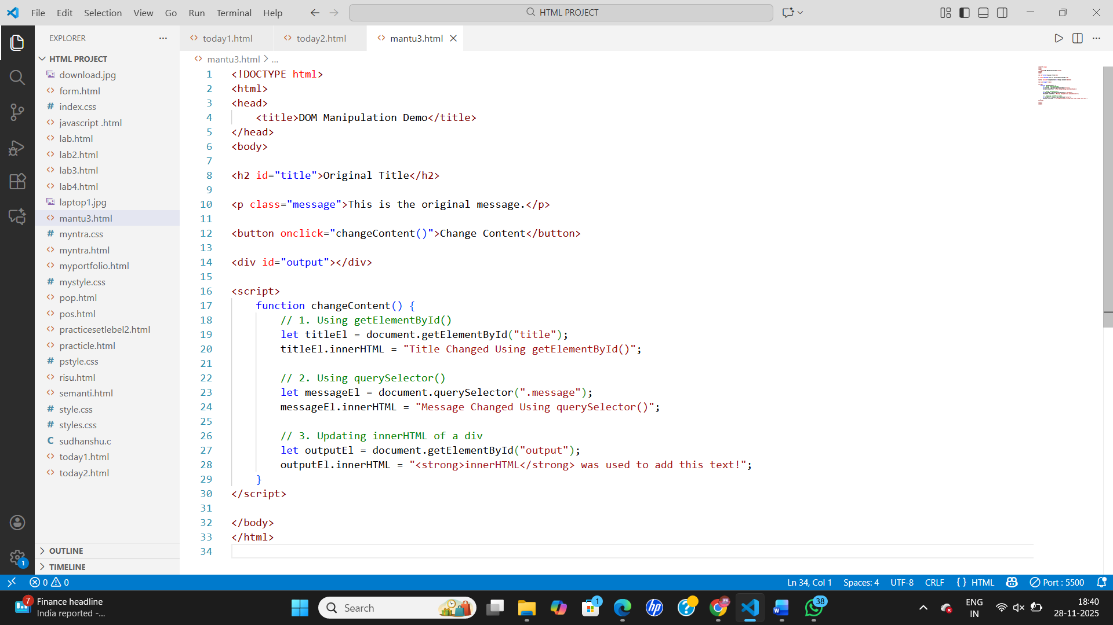
Output
